Upper Strings
Read a sequence of strings, given on a single line separated with a space.
Map each to upper case and print them, using LINQ.
Examples
Input | Output
Pesho Gosho Stefan | PESHO GOSHO STEFAN
Soft Uni Rocks | SOFT UNI ROCKS
(empty line) | (no output)
Hints
Read the input into a list of strings List<string>:
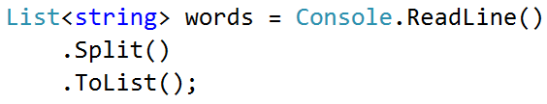
Use the Select() method to change every element of the list of words to uppercase. Iterate over the words and print the result:
